import 'package:flutter/material.dart';

void main(){
runApp(MyApp());
}

class MyApp extends StatelessWidget {
const MyApp({super.key});

@override
Widget build(BuildContext context) {
return MaterialApp(
debugShowCheckedModeBanner: false,
home: Scaffold(
appBar: AppBar(
title: Text("ONYX T-Shirt Collection",
style: TextStyle(
color: Colors.white,
),
),
backgroundColor: const Color.fromARGB(255, 8, 6, 99),
centerTitle: true,
leading: Icon(
Icons.menu,
size: 20,
color: Colors.white,

),
actions: [
Icon(Icons.search),
],
),
body: Center(
child: Text("Welcome again!!",
style: TextStyle(
fontFamily: "times New Roman",
fontSize: 50,
color: Colors.red
),
),
),
),
);
}
}
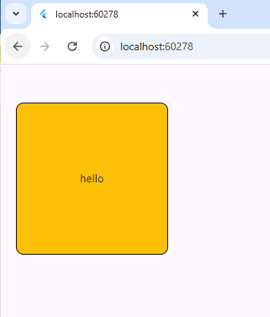
import 'package:flutter/material.dart';

void main(){
runApp(MyApp());
}

class MyApp extends StatelessWidget {
const MyApp({super.key});

@override
Widget build(BuildContext context) {
return MaterialApp(
debugShowCheckedModeBanner: false,
home: SafeArea(
child: Scaffold(
body: Container(

width: 200,
height: 200,
margin: EdgeInsets.fromLTRB(20,50,40,50),
padding: EdgeInsets.all(30),
decoration: BoxDecoration(
borderRadius: BorderRadius.circular(10),
color: Colors.amber,
border: Border.all(
color: Colors.black,
width: 1
)
),
child: Center(
child: Text("hello"),
)
),
),
),
);
}
}

import 'package:flutter/material.dart';

void main(){
runApp(MyApp());
}

class MyApp extends StatelessWidget {
const MyApp({super.key});

@override
Widget build(BuildContext context) {
return MaterialApp(
debugShowCheckedModeBanner: false,
home: Scaffold(
appBar: AppBar(
title: Text("ONYX COLLECTION",style: TextStyle(
color: Colors.white,
fontFamily: "times new roman",
),
),
backgroundColor: const Color.fromARGB(255, 20, 13, 63),
centerTitle: true,

leading: Icon(
Icons.menu,
color: Colors.white,
),
actions: [
Icon(
Icons.search,
color: Colors.white
),
],
),
body: SafeArea(
child: Container(

height: 200,
width: 200,
margin: EdgeInsets.fromLTRB(20, 30, 40, 50),
decoration: BoxDecoration(
color: Colors.amber,
borderRadius: BorderRadius.circular(20),
),
child: Center(
child: Text("product"),

)
),
),
),
);
}
}

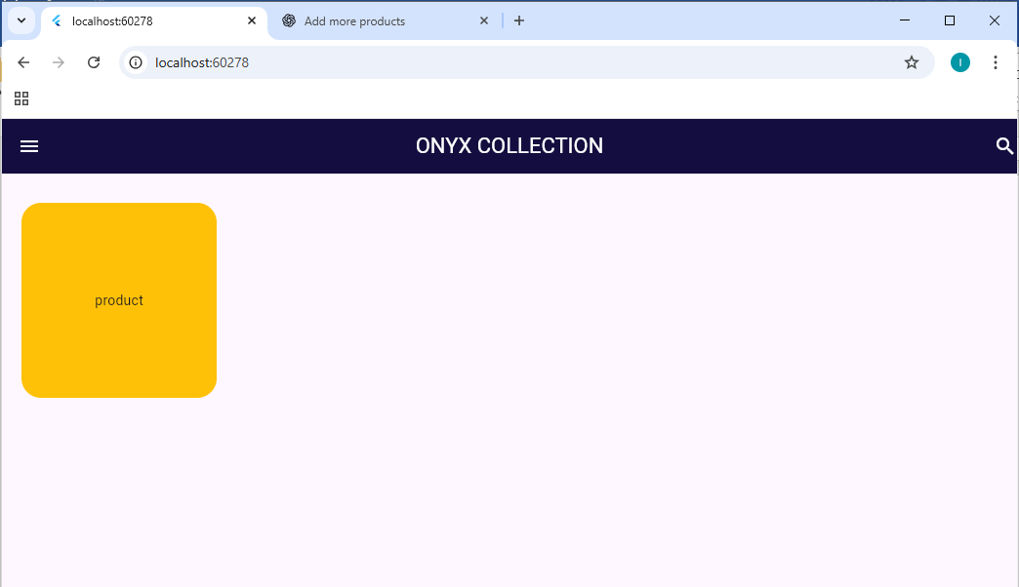

import 'package:flutter/material.dart';

void main(){
runApp(MyApp());
}

class MyApp extends StatelessWidget {
const MyApp({super.key});

@override
Widget build(BuildContext context) {
return MaterialApp(
debugShowCheckedModeBanner: false,
home: SafeArea(
child: Scaffold(
appBar: AppBar(
title: Text("ONYX COLLECTION",style: TextStyle(
color: Colors.white
),),
backgroundColor: const Color.fromARGB(255, 7, 6, 71),
leading: Icon(
Icons.menu,
color: Colors.white,
),
actions: [
Icon(
Icons.search,
color: Colors.white,
)
],
centerTitle: true,
),
body: Column(
children: [
Container(

height: 200,
width: 200,
margin: EdgeInsets.all(20),
decoration: BoxDecoration(
color: const Color.fromARGB(255, 7, 6, 71),
borderRadius: BorderRadius.circular(20)
),
child: Center(
child: Text("product",
style: TextStyle(
color: Colors.white,
),
),
),
),
Container(

height: 200,
width: 200,
margin: EdgeInsets.all(20),
decoration: BoxDecoration(
color: const Color.fromARGB(255, 7, 6, 71),
borderRadius: BorderRadius.circular(20)
),
child: Center(
child: Text("product",
style: TextStyle(
color: Colors.white
),
),
),

)
],
),
),
),
);
}
}
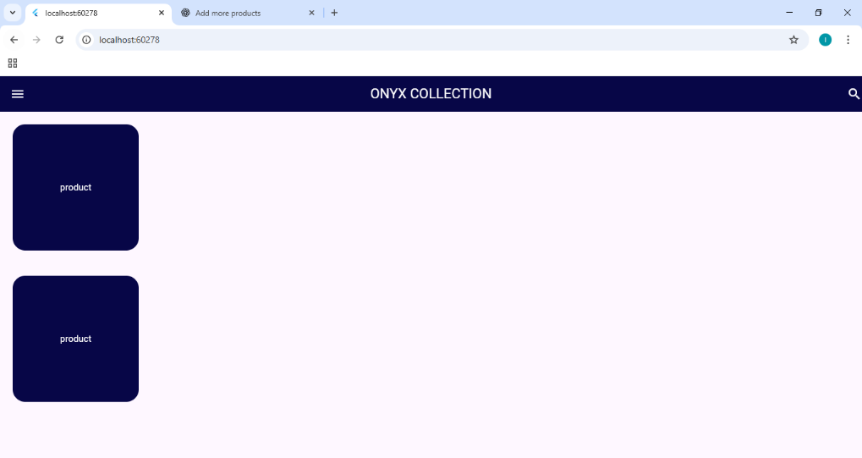

import 'package:flutter/material.dart';

void main(){
runApp(MyApp());
}

class MyApp extends StatelessWidget {
const MyApp({super.key});

@override
Widget build(BuildContext context) {
return MaterialApp(
debugShowCheckedModeBanner: false,
home: SafeArea(
child: Scaffold(
appBar: AppBar(
title: Text("ONYX COLLECTION",style: TextStyle(
color: Colors.white
),),
backgroundColor: const Color.fromARGB(255, 7, 6, 71),
leading: Icon(
Icons.menu,
color: Colors.white,
),
actions: [
Icon(
Icons.search,
color: Colors.white,
)
],
centerTitle: true,
),
body: Container(
color: Colors.amber,
height: 400,
width: 400,
child: Column(

crossAxisAlignment:CrossAxisAlignment.stretch,
children: [
Container(
color: Colors.red,
height: 100,
width: 300,
child: Text("hello"),

),
Container(
color: const Color.fromARGB(255, 54, 244, 54),
height: 100,
width: 300,
child: Text("hello"),

),
Container(
color: const Color.fromARGB(255, 82, 54, 244),
height: 100,
width: 300,
child: Text("hello"),

),
],
),
),
),
),
);
}
}
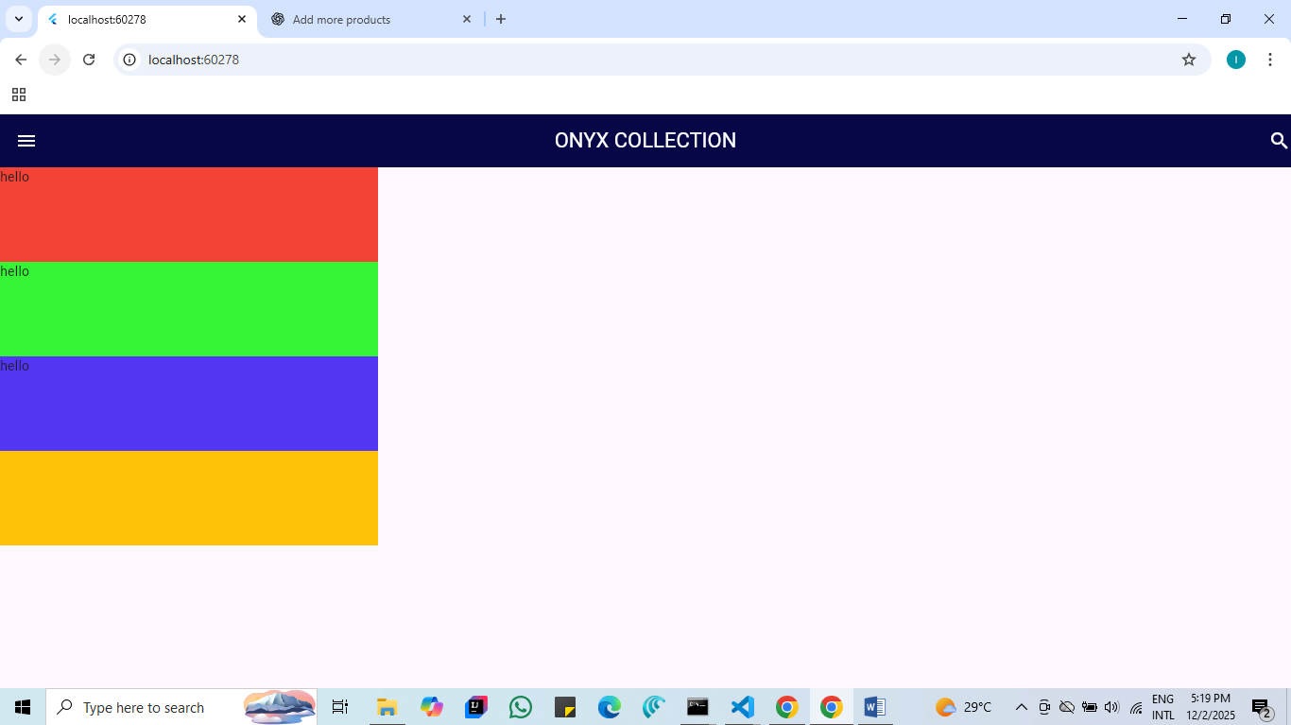

import 'package:flutter/material.dart';

void main(){
runApp(MyApp());
}

class MyApp extends StatelessWidget {
const MyApp({super.key});

@override
Widget build(BuildContext context) {
return MaterialApp(
debugShowCheckedModeBanner: false,
home: Scaffold(
appBar: AppBar(
title: Text("ONYX COLLECTION",
style: TextStyle(
color: Colors.white,
),
),
backgroundColor: const Color.fromARGB(255, 5, 9, 58),
centerTitle: true,

leading: Icon(
Icons.menu,
color: Colors.white,
),
actions: [
Icon(
color: const Color.fromARGB(255, 255, 255, 255),
Icons.search)
],
),
body: Container(
color: const Color.fromARGB(183, 224, 220, 207),
margin: EdgeInsets.fromLTRB(10, 20, 10, 20),

child: Row(

mainAxisAlignment: MainAxisAlignment.spaceEvenly,
crossAxisAlignment: CrossAxisAlignment.center,

children: [

Container(

height: 200,
width: 200,
decoration: BoxDecoration(
color: const Color.fromARGB(255, 28, 70, 99),
borderRadius: BorderRadius.circular(10)),
child: Center(
child: Text("Product 1",style: TextStyle(
color: Colors.white,
),),
),
),

Container(
height: 200,
width: 200,
decoration: BoxDecoration(
color: const Color.fromARGB(255, 28, 70, 99),
borderRadius: BorderRadius.circular(10)),
child: Center(
child: Text("Product 1",style: TextStyle(
color: Colors.white,
),),
),

),

Container(
height: 200,
width: 200,
decoration: BoxDecoration(
color: const Color.fromARGB(255, 28, 70, 99),
borderRadius: BorderRadius.circular(10)),
child: Center(
child: Text("Product 1",style: TextStyle(
color: Colors.white,
),),
),

),
Container(
height: 200,
width: 200,
decoration: BoxDecoration(
color: const Color.fromARGB(255, 28, 70, 99),
borderRadius: BorderRadius.circular(10)),
child: Center(
child: Text("Product 1",style: TextStyle(
color: Colors.white,
),),
),

),
Container(
height: 200,
width: 200,
decoration: BoxDecoration(
color: const Color.fromARGB(255, 28, 70, 99),
borderRadius: BorderRadius.circular(10)),
child: Center(
child: Text("Product 1",style: TextStyle(
color: Colors.white,
),),
),

)

],
),
),

),
);
}
}

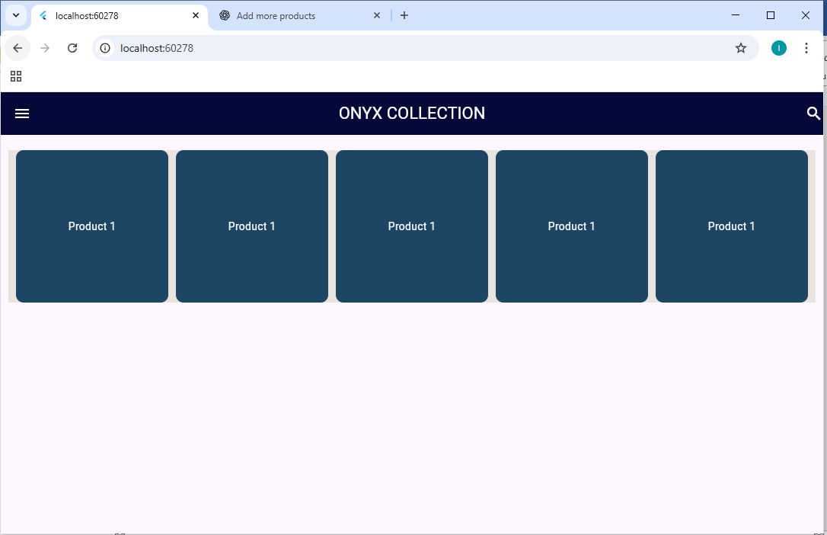

import 'package:flutter/material.dart';

void main() {
runApp(MyApp());
}

class MyApp extends StatelessWidget {
const MyApp({super.key});

@override
Widget build(BuildContext context) {
return MaterialApp(
debugShowCheckedModeBanner: false,
home: Scaffold(
appBar: AppBar(
title: Text("ONYX COLLECTION", style: TextStyle(color: Colors.white)),
backgroundColor: const Color.fromARGB(255, 5, 9, 58),
centerTitle: true,

leading: Icon(Icons.menu, color: Colors.white),
actions: [
Icon(color: const Color.fromARGB(255, 255, 255, 255), Icons.search),
],
),
body: SingleChildScrollView(
child: Column(
children: [
Row(
mainAxisAlignment: MainAxisAlignment.center,
children: [
Center(
child: Padding(
padding: EdgeInsets.all(20),
child: Text(
"WELCOME AND CHOOSE YOUR'S ONE",
style: TextStyle(
fontSize: 50,
color: const Color.fromARGB(255, 2, 20, 49),
),
),
),
),
],
),
SizedBox(height: 20),

Row(
mainAxisAlignment: MainAxisAlignment.spaceEvenly,

children: [
Container(
height: 200,
width: 200,
color: Colors.amber,
child: Text("product"),
),
Container(
height: 200,
width: 200,
color: Colors.amber,
child: Text("product"),
),
Container(
height: 200,
width: 200,
color: Colors.amber,
child: Text("product"),
),
],
),

SizedBox(height: 20),

Row(
mainAxisAlignment: MainAxisAlignment.spaceEvenly,

children: [
Container(
height: 200,
width: 200,
color: Colors.amber,
child: Text("product"),
),
Container(
height: 200,
width: 200,
color: Colors.amber,
child: Text("product"),
),
Container(
height: 200,
width: 200,
color: Colors.amber,
child: Text("product"),
),
],
),
SizedBox(height: 20),
Row(
mainAxisAlignment: MainAxisAlignment.spaceEvenly,

children: [
Container(
height: 200,
width: 200,
color: Colors.amber,
child: Text("product"),
),
Container(
height: 200,
width: 200,
color: Colors.amber,
child: Text("product"),
),
Container(
height: 200,
width: 200,
color: Colors.amber,
child: Text("product"),
),
],
),
SizedBox(height: 20),
],
),
),
),
);
}
}

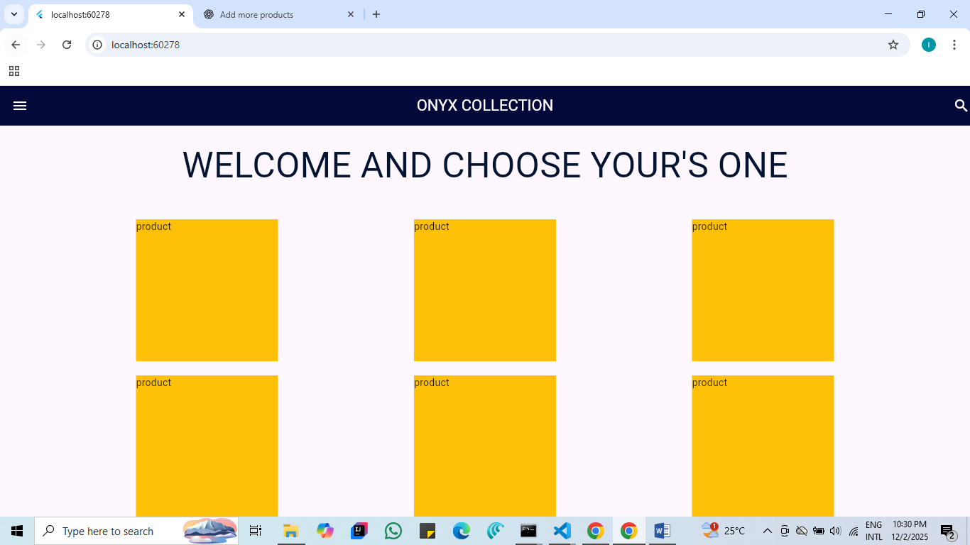

import 'package:flutter/material.dart';

void main(){
runApp(MyApp());
}

class MyApp extends StatelessWidget {
const MyApp({super.key});

@override
Widget build(BuildContext context) {
return MaterialApp(
debugShowCheckedModeBanner: false,
home: Scaffold(
appBar: AppBar(
backgroundColor: const Color.fromARGB(255, 2, 33, 58),
title: Text("ONYX COLLECTION",
style: TextStyle(
color: Colors.white,

),
),
centerTitle: true,
leading: Icon(
Icons.menu,
color: Colors.white,
),
actions: [
Icon(
Icons.search,
color: Colors.white,

)
],
),
body: Container(
margin:EdgeInsets.fromLTRB(10, 0, 10, 0),
child: Column(
crossAxisAlignment: CrossAxisAlignment.stretch,
mainAxisAlignment: MainAxisAlignment.spaceEvenly,
children: [
Container(
height: 250,
width: 200,
color: Colors.green,
),
Container(
height: 250,
width: 200,
color: Colors.deepPurpleAccent,
)
],
),
),
),
);
}
}
